**Lab Practice Guide – 6**

**HTML**

**Case Study 1**

**Design a HTML page to display the following table in the page.**

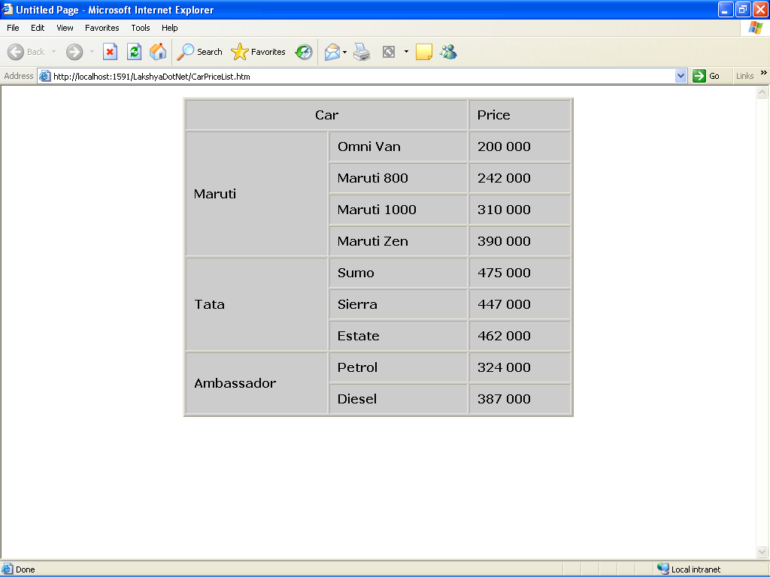

**Case Study 2**

**Design a sample Form in html for the Training Annual Convention** as follow.

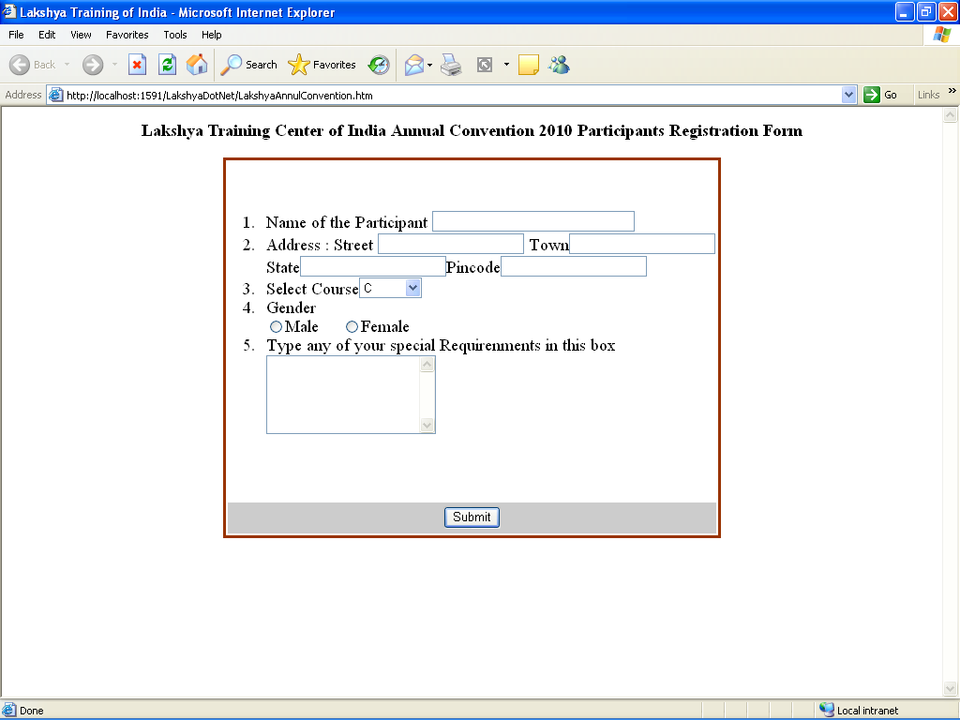

**Case Study 3**

**Create a frameset page in html as follows. Display different pages or images in each frame.**

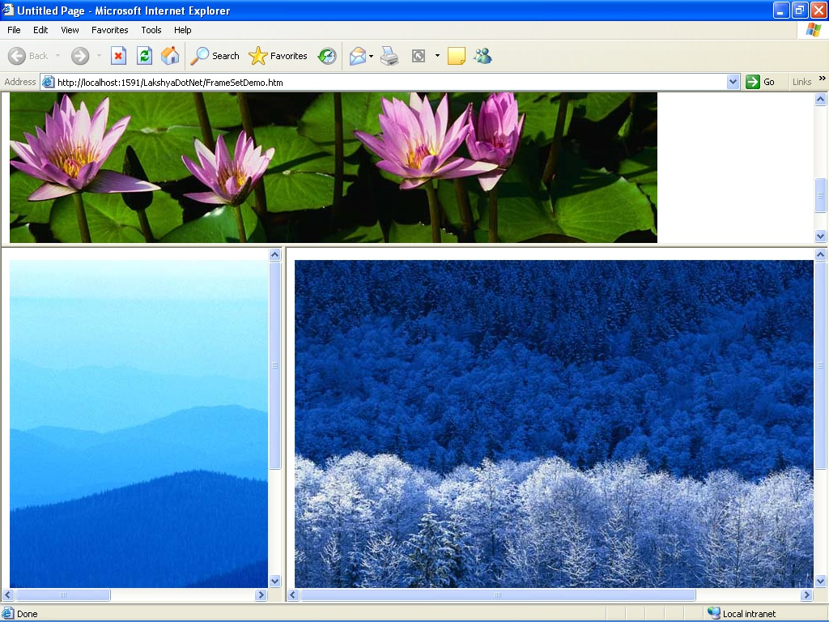

**Java Script**

**Case Study 4**

Write a program in java script to find the factorial of a number.

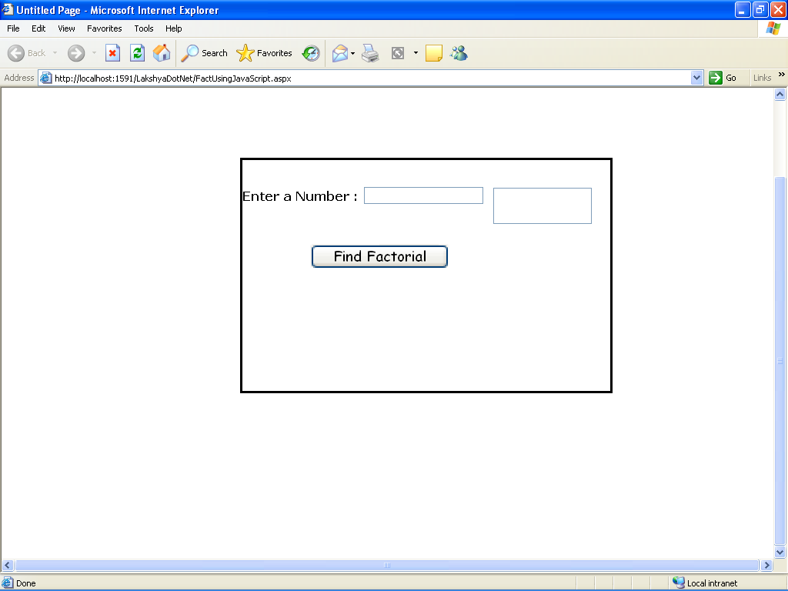

**Case Study 5**

Write a program in java script to accept only alphabets in textbox.

**Case Study 6**

Create a web form, place a Textbox control into it. When a user Enter data in the Textbox. It accepts only alphabets (a-z) .After insert data inside the text box it checked the first character of the string should be Uppercase. (Using JavaScript)

**Case Study 7**

Take a radio button list on the page containing color name as red, blue, black, green, etc. If user selects any option the background color of the page make be changed.

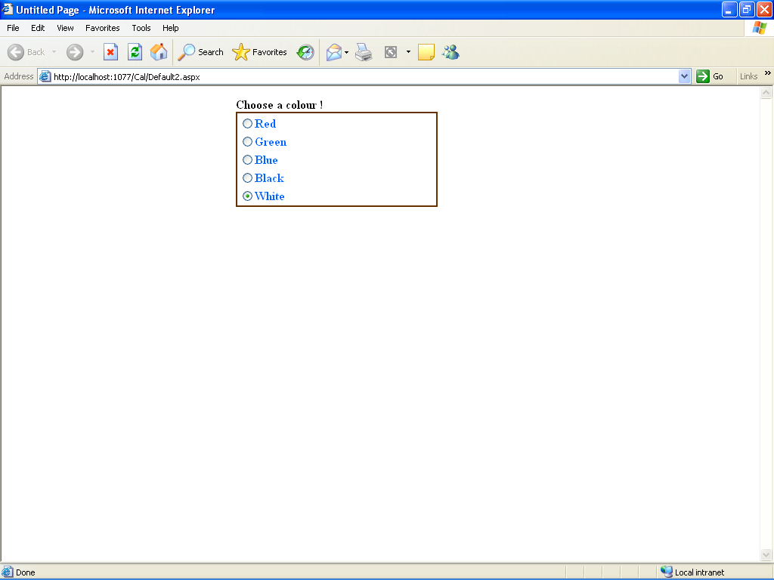

**Case Study 8**

Create a web form, place a gridview control into it. Display records from a database table in it. Also allow it to perform following operation:

1. Select an entire Record
2. Edit the Selected Record
3. Delete the selected Record
4. Insert a new Record

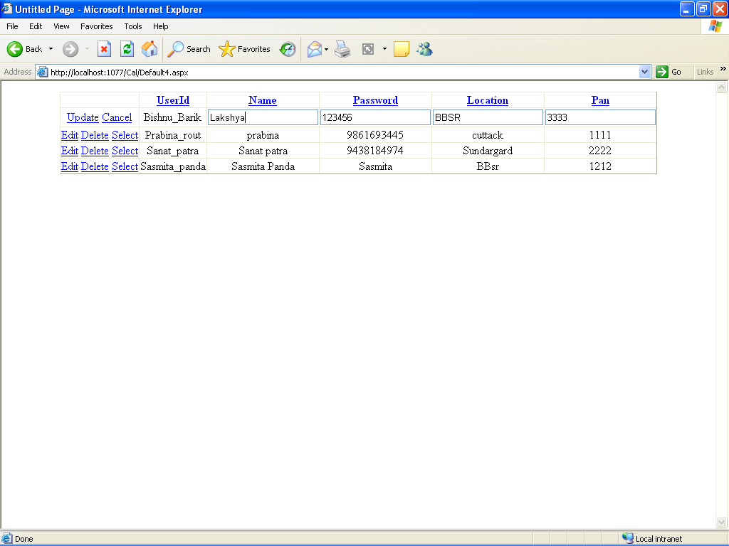

**Case Study 11**

Create a web application showing the use of validation controls i.e. required field validator, range validator, regular expression validator etc.

**Case Study 12**

Create a web page for Login using Login control. If the userid and password is valid than it redirect to another page where userid will be displayed in a label as Hello <userid>

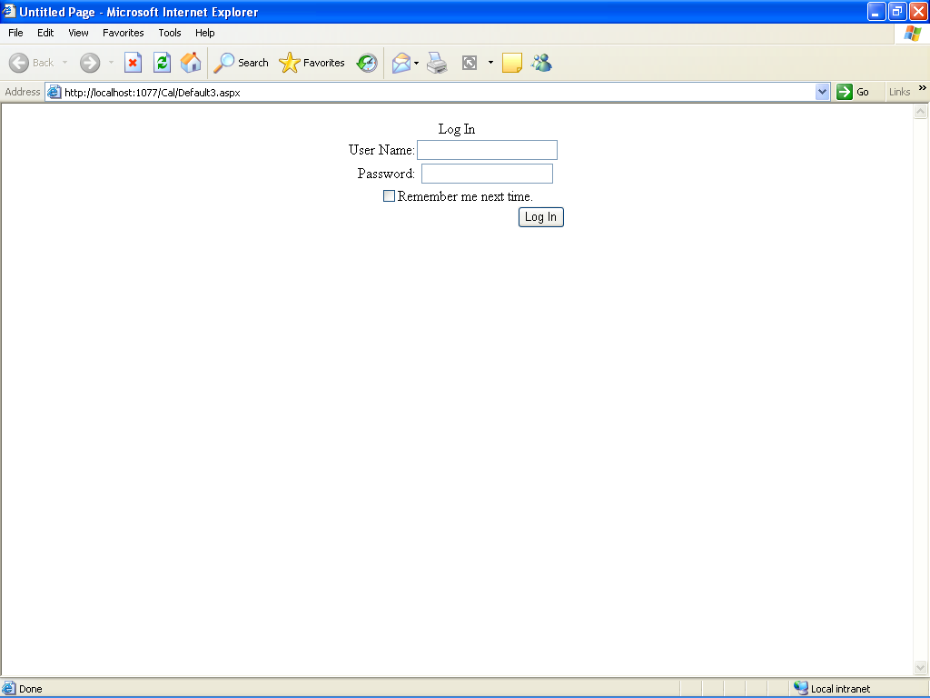

**Case Study 13**

Create a web application that uses Navigation controls (i.e. sitemap, tree view & menu navigator) for easy navigation among various pages of the web application.

